**Programming Fundamentals**

**Lab Report**

**Lab 07**



|  |  |
| --- | --- |
| Group Members Name & Reg #: | **Muhammad Haris Irfan**  **(FA18-BCE-090)** |
|  |  |
| Class | Programming Fundamentals CSC103 (**BCE-2B**) |
| Instructor’s Name | Dilshad Sabir |

**In Lab Tasks**

**Question no: 1**

Using the Notepad (the Windows text editor), save the program given in Code Listing 1 as a C **file (test1.c).** Then use the **GNU CLI** to compile the program and generate the intermediate files like, **test1.i**, **test1.s**, **test1.o** and finally **test1.exe**

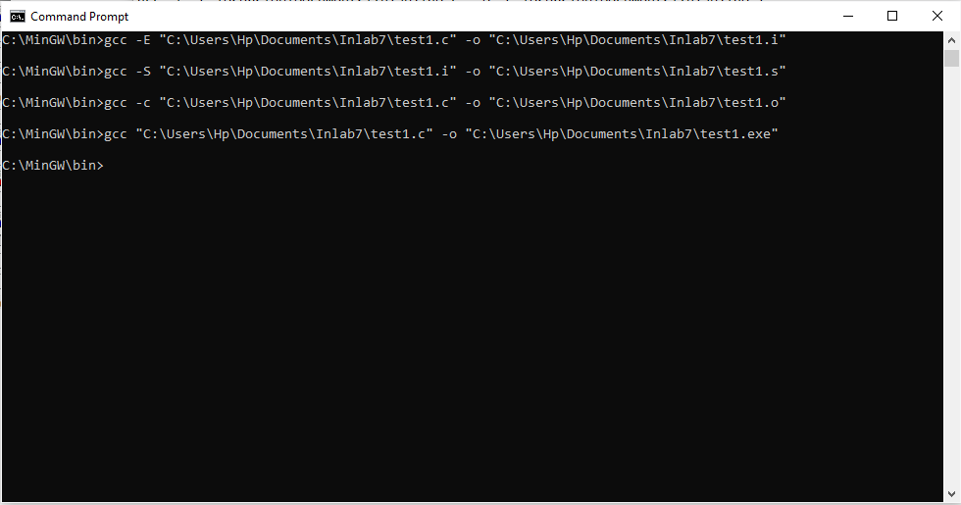**Solution:**

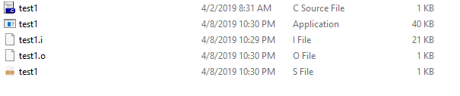

-------------------------------

**Question no: 2(a)**

Using the Notepad (the Windows text editor), save the programs given in Code Listing 2, 3 and 4 as c/h files (primes.h, primes.c, and go.c). Then use the GNU CLI to compile the program and generate the intermediate files like, go.i, go.s, go.o and finally go.exe.

Solution

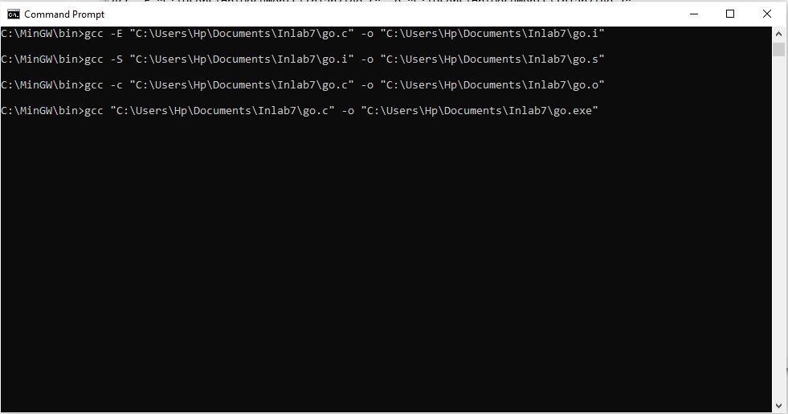

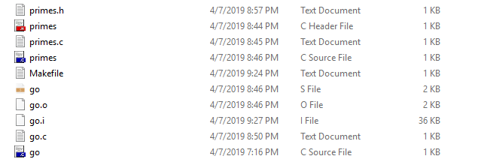

------------------------------

THE END